Answers to questions in

Lab 1: Filtering operations

Name: Markus Brislöv___________________________________ Program: AUSY ____________________

**Instructions**: Complete the lab according to the instructions in the notes and respond to the questions stated below. Keep the answers short and focus on what is essential. Illustrate with figures only when explicitly requested.

Good luck!

___________________________________________________________________________

**Question 1**: Repeat this exercise with the coordinates p and q set to (5, 9), (9, 5), (17, 9),

(17, 121), (5, 1) and (125, 1) respectively. What do you observe?

Answers:

Depending on the given coordinates a difference in the sinewave can be observed relating to its frequency and orientation.

___________________________________________________________________________

**Question 2**: Explain how a position (p, q) in the Fourier domain will be projected as a sine wave in the spatial domain. Illustrate with a MATLAB figure.

Answers:

In the Fourier domain a point (p, q) represents two orthogonal frequencies, $ω_{1}$ and $ω_{2}$. For instance, a point (10, 1) will generate a sinewave oriented vertically with $ω_{1}=9$ and $ω_{2}=0$ as frequencies. The relationship between frequency and coordinates are $ω_{1}=p-1$ and $ω_{2}=q-1$ due to indices starting at 1 in MATLAB.

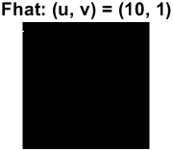  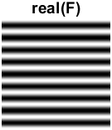

If the given point was (1, 10) the sinewave would be oriented horizontally.

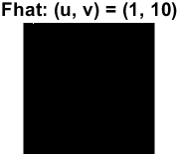  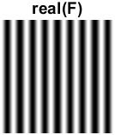

A point (10, 10) yields a sinewave oriented in 45 degrees (origin upper left corner).

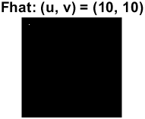  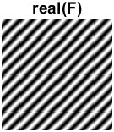

___________________________________________________________________________

**Question 3**: How large is the amplitude? Write down the expression derived from Equation (4) in the notes. Complement the code (variable amplitude) accordingly.

Answers:

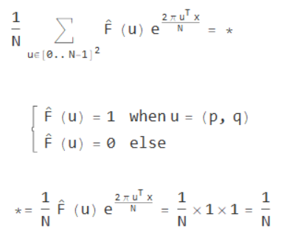

The amplitude can therefore be calculated accordingly in the code:

$$amplitude = 1 / sz;$$

___________________________________________________________________________

**Question 4**: How does the direction and length of the sine wave depend on p and q? Write down the explicit expression that can be found in the lecture notes. Complement the code (variable wavelength) accordingly.

Answers:

The length can be calculated with the following formula:

$$λ=\frac{1}{\sqrt{u^{2}+v^{2}}}$$

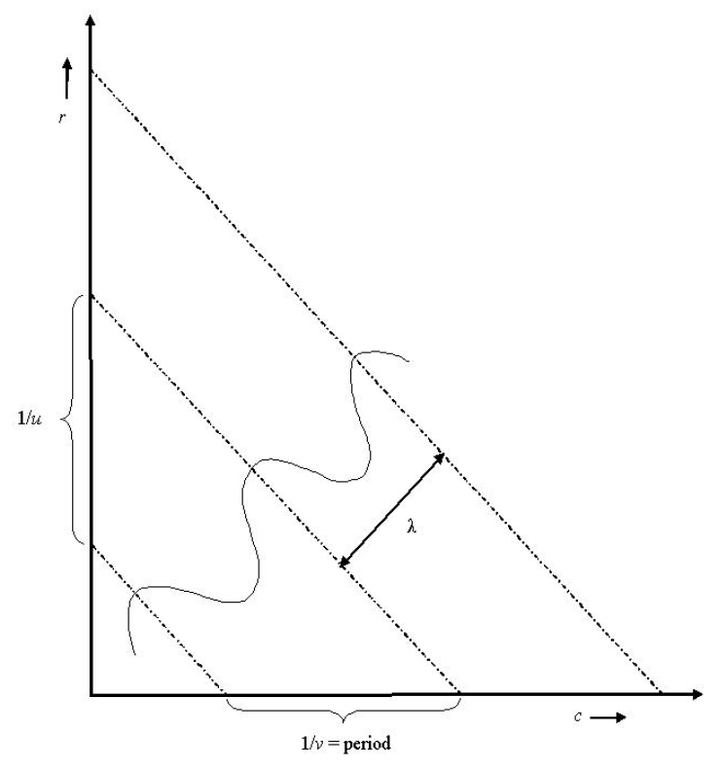

And the angle for a point (p, q):

$$α=arctan⁡(q/p)$$

___________________________________________________________________________

**Question 5**: What happens when we pass the point in the center and either p or q exceeds half the image size? Explain and illustrate graphically with MATLAB!

Answers:

When either p or q exceeds half the image size its corresponding frequency becomes negative. The values are mirrored around (65, 65) which can be seen in the following images.

 

 

 

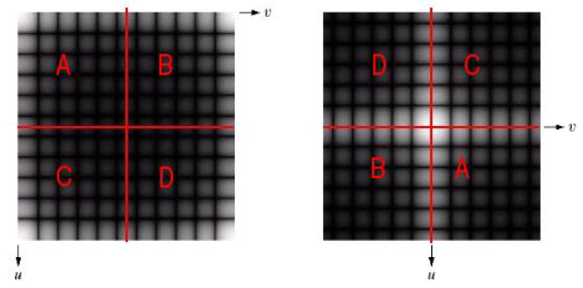

___________________________________________________________________________

**Question 6**: What is the purpose of the instructions following the question *What is done by these instructions?* in the code?

Answers:

There are two purposes, one is due to indices starting at 1 in MATLAB, which requires that the coordinates are subtracted by one if they are less than half of the image size. This allows us to get the correct frequencies.

$$uc = u - 1;$$

$$vc = v - 1;$$

The other is convert the coordinates, given they are above half the image size, to negative values, negative frequencies.

$$uc = u - 1 - sz; \\ vc = v - 1 - sz;$$

___________________________________________________________________________

**Question 7**: Why are these Fourier spectra concentrated to the borders of the images? Can you give a mathematical interpretation? Hint: think of the frequencies in the source image and consider the resulting image as a Fourier transform applied to a 2D function. It might be easier to analyze each dimension separately!

Answers:

From the image in the spatial domain we see that we only have changes along the vertical axis which is why we can only see frequencies along the border of the vertical axis *u* in the Fourier spectra.

 

Therefore, we only have non-zero values when $v=0$. By looking at the 1D discrete Fourier transform along the vertical axis, we can see that the sum becomes 0 at all other values expect $v=0→e^{0}=1$. This can be simplified by a discrete Dirac delta function:

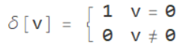

By using this knowledge, we can simplify the 2D discrete Fourier transform:

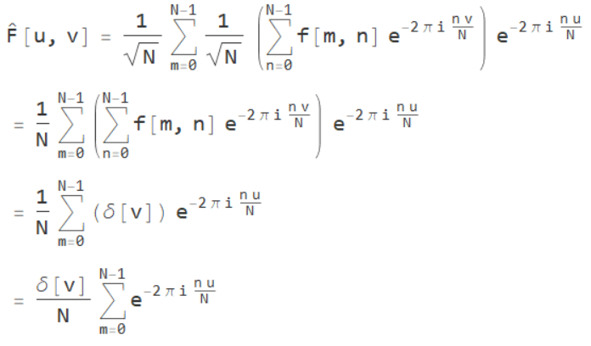

___________________________________________________________________________

**Question 8**: Why is the logarithm function applied?

Answers:

To compress the dynamic range of the image which helps with revealing features in an image where the dynamic range is too large to be displayed. It works by enhancing the lower values and compressing higher values, which can be seen in the following images.

 

 

___________________________________________________________________________

**Question 9**: What conclusions can be drawn regarding linearity? From your observations can you derive a mathematical expression in the general case?

Answers:

Its linear, because addition and multiplication can be done either before or after applying the Fourier transform. Order doesn’t matter when it’s linear.



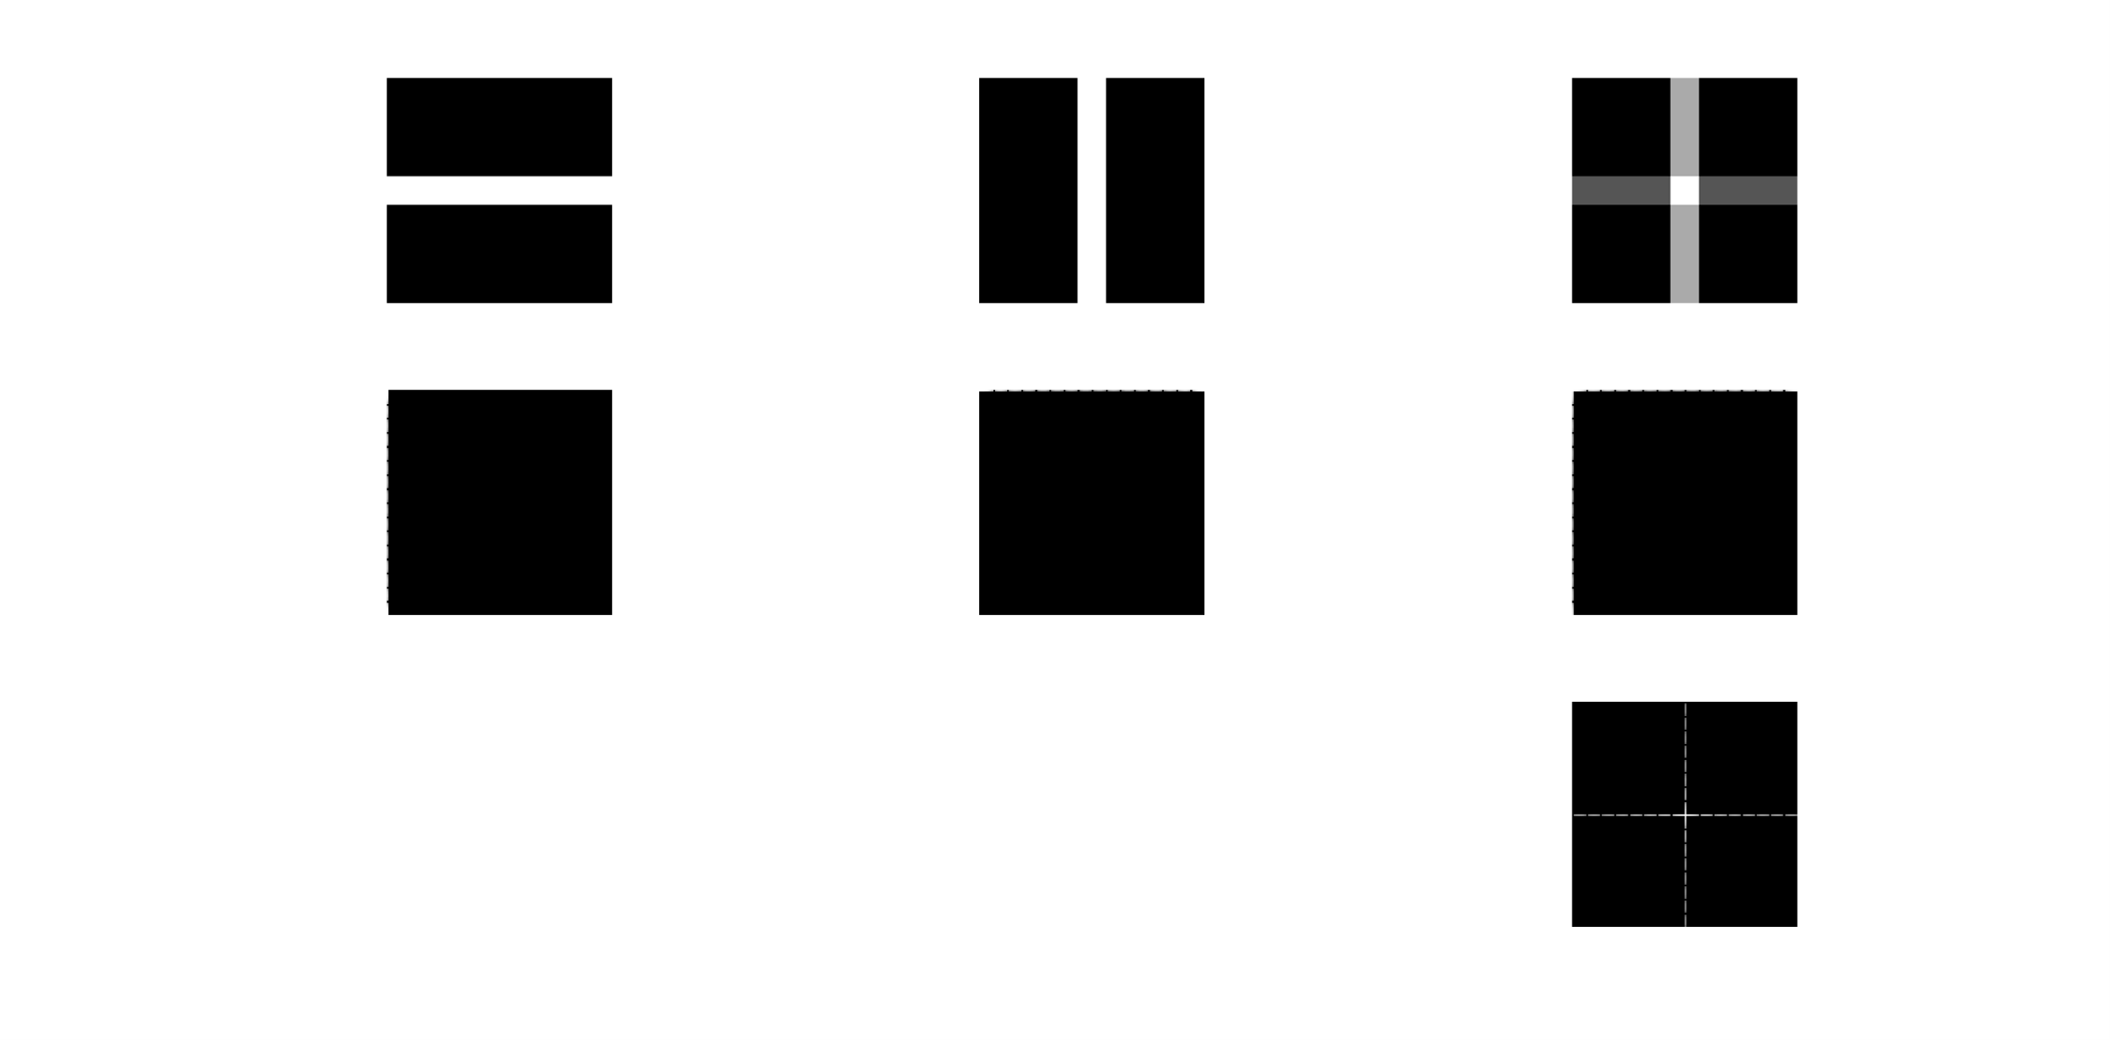

___________________________________________________________________________

**Question 10**: Are there any other ways to compute the last image? Remember what multiplication in Fourier domain equals to in the spatial domain! Perform these alternative computations in practice.

Answers:

Multiplication in the spatial domain is same as convolution in the Fourier domain.[1]

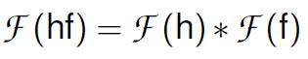

That is, the pointwise multiplication in the spatial here is the same as the convolution in the frequency domain.

 



___________________________________________________________________________

**Question 11**: What conclusions can be drawn from comparing the results with those in the previous exercise? See how the source images have changed and analyze the effects of scaling.

Answers:



Comparing the images, we can see that when something is scaled up in the spatial domain corresponds to compression in the Fourier domain. Additionally, scaling down in the spatial domain corresponds to expansion in the Fourier domain.

Conclusion: compression in spatial domain is same as expansion in Fourier domain (and vise versa).[2]

___________________________________________________________________________

**Question 12**: What can be said about possible similarities and differences? Hint: think of the frequencies and how they are affected by the rotation.

Answers:



When an image is rotated in the spatial domain its representation in the Fourier domain will rotate accordingly. Varying amounts of noise is introduced from the rotation which is due to the constrains for discretization of a diagonal line.



From the above figure we can see that to represent each of the different rows require a different set of frequencies which can be see as noise in the Fourier domain. This is also true for the columns.

___________________________________________________________________________

**Question 13**: What information is contained in the phase and in the magnitude of the Fourier transform?

Answers:



The phase contains information about the starting point for each sine wave that the image can be decomposed into. It determines where the edges are in the image.

The magnitude describes the amplitude of the sine wave which determines the pixel intensity in the image, which is why we lose grey-level information in the images where *pow2image()* has been applied.

In conclusion, the phase is more important for identified objects in an image than the magnitude.

___________________________________________________________________________

**Question 14**: Show the impulse response and variance for the above-mentioned t-values. What are the variances of your discretized Gaussian kernel for t = 0.1, 0.3, 1.0, 10.0 and

100.0?

Answers:



|  |  |
| --- | --- |
| t | Covariance |
| 0.1 | 0.0133 0.0000  0.0000 0.0133 |
| 0.3 | 0.2811 0.0000  0.0000 0.2811 |
| 1.0 | 1.0000 0.0000  0.0000 1.0000 |
| 10.0 | 10.0000 0.0000  0.0000 10.0000 |
| 100.0 | 100.000 0.0000  0.0000 100.0000 |

___________________________________________________________________________

**Question 15**: Are the results different from or similar to the estimated variance? How does the result correspond to the ideal continuous case? Lead: think of the relation between spatial and Fourier domains for different values of t.

Answers:

When variance t is set below 1.0 some notable error is introduced in the covariance matrix of the Gaussian function. Because we are discretizing the Gaussian function it will deviate from correct Gaussian values when t is set too low. This doesn’t happen to the same degree when t > 1.0 which is why we are not seeing any errors in those covariance matrices.

___________________________________________________________________________

**Question 16**: Convolve a couple of images with Gaussian functions of different variances (like t = 1.0, 4.0, 16.0, 64.0 and 256.0) and present your results. What effects can you observe?

Answers:



A low variance in the spatial domain becomes a high variance in the Fourier domain and vice versa. Therefore, a low *t* value still gives us a sharp image since most high frequencies are still included. When *t* increases more of the high frequencies are suppressed and the image gets blurrier.

___________________________________________________________________________

**Question 17**: What are the positive and negative effects for each type of filter? Describe what you observe and name the effects that you recognize. How do the results depend on the filter parameters? Illustrate with Matlab figure(s).

Answers:

**Gaussian smoothing**





As we found out earlier, a higher *t* value suppresses a larger amount of the higher frequencies. From the images we can see a larger improvement when there is gaussian noise compared to sap noise. But, to filter out the noise will also filter out the frequencies that produces the sharp edges. This results in blurry edges, and a blurry image in general.

**Median filtering**





Median filtering works by looking at the neighborhood values and finds the median of those, where *m* is the width and height of the pixels where the median will be found. Therefore, a higher value will increase the painting-like effect this filter has and increase the loss of information in the image. Because we don’t work with suppressing frequencies the loss of sharpness doesn’t occur as fast as with Gaussian smoothing. From the tested images above we can see due to the nature of the median filter that it works best in removing sap noise.

**Ideal low-pass**





Ideal low-pass filter works by removing all frequencies higher than the given cuttoff frequency. For the given images a value around 0.15 – 0.25 seemed to give the best possible result. It performed slightly better on gaussian noise compared to sap but worse than the other previously used fitlers. For small cutoff values a grid like patterns apear in the image.

___________________________________________________________________________

**Question 18**: What conclusions can you draw from comparing the results of the respective methods?

Answers:

Gaussian smoothing performed the best in minimizing gaussian noise. Creates a blurry image.

Median filter worked best for sap noise but also worked well for gaussian noise. Creates a painting-like image if too much is applied.

Ideal low-pass filter performed the worst out of the three filters. Did help with reducing gaussian noise but does not work well for SAP noise. Creates a grid-like patterns with low cutoff values (Gibs phenomenon).

___________________________________________________________________________

**Question 19**: What effects do you observe when subsampling the original image and the smoothed variants? Illustrate both filters with the best results found for iteration i = 4.

Answers:

First row is raw subsampling, second gaussian and third is ideal low-pass filter.





The raw subsampled image become noisy.

Gaussian smoothing before subsampling results in a blurry image.

Ideal low-pass introduces artifacts and makes the image blurrier.

___________________________________________________________________________

**Question 20**: What conclusions can you draw regarding the effects of smoothing when combined with subsampling? Hint: think in terms of frequencies and side effects.

Answers:

If the subsampling is done on an image with too high frequencies these frequencies will fold (aliasing) into the lower frequencies and distort and add noise and artifacts to the image. By blurring before subsampling we can remove the high frequencies before subsampling so this doesn’t occur.

___________________________________________________________________________

1. Lecture 4, page 20
2. Lecture 4, page 15